SOCIAL STATISTICS
SOC 24100

Exam #1

Name _________________ Date _________________

You are currently interning at the Stone Center on Socio-Economic Inequality, CUNY, and your mentor has asked you to prepare a report on gender inequality on the U.S. labor market. Since you are still relatively unfamiliar with the data, they have kindly provided you with the following material:

- 1 outline for your research report
- 1 project summary
- 6 variable descriptions
- 2 raw data tables
- 2 frequency distribution tables
- 2 percentage distribution tables
- 2 graphs
- 1 bivariate table

As you write your report, feel free to use one or more pieces of information to slowly build your analysis.

Formulas you might need:

1. Mean
$\overline{χ}$=
$$S_{y}^{2}=\frac{\sum{{\left(Y-\overline{Y}\right)}^{2}}}{N-1}$$
2. Variance

$$S_{Y}=\sqrt{\frac{\sum{{\left(Y-\overline{Y}\right)}^{2}}}{N-1}}$$

3. Standard Deviation

            - Research Report Outline
- Introduction

A good introduction summarizes a study’s research question, the research hypothesis under investigation, the variables used for the analysis, as well as the key findings. Let’s begin with the first three components (hint: you might want to take a quick glance at the project summary):

  - What is the main question your research report is trying to answer? (2 points)

How large is the gender gap pay gap currently in the U.S?

  - What was the researchers’ hypothesis, i.e. what did the researchers at the Stone Center expect to find? (2 points)
Ho: there is currently a gender pay gap in the U.S
H1: there is no currently a gender pay gap in the U.S

  - What were the two main variables under investigation? (2 points)

            - Gender(men,women).
            - Income.

  - Which one was the independent, which one the dependent variable? (2 points)

Gender=independent.
Income =dependent.

- Methodology

Methods sections typically begin with a detailed description of all variables included in the analysis, particularly their level of measurement. To connect your Methodology with your Descriptive Statistics section, you should not forget to include some descriptive tables (hint: how about taking a look at the variable descriptions?):

  - What is the level of measurement of all variables included in the analysis? (2 points each)

Age of respondent: nominal

Annual income: interval

Labor force status: ordinal

Race: nominal

Gender: nominal

Years of education: nominal

  - For your independent and dependent variable only: Construct a percentage distribution table, taking the frequency distribution tables as a starting point. Include cumulative percentages if appropriate. (hint: you could simply add extra columns to the frequency distribution tables)
(15 points)

Respondent’s income | Male (in %) | Female (in %) | Total (in %) | Male(cumulative) | Female(cumulative) | Total (cimulative)
Less than $1000 | 2.31 | 2.72 | 2.53 | 2.31 | 2.72 | 2.53
$1000 to $2999 | 1.49 | 3.30 | 2.45 | 3.8 | 6.02 | 4.98
$3000 to $3999 | 1.49 | 3.30 | 2.45 | 5.29 | 9.32 | 7.43
$4000 to $4999 | 1.65 | 1.58 | 1.61 | 6.94 | 10.9 | 9.04
$5000 to $5999 | 1.32 | 1.86 | 1.61 | 8.26 | 12.76 | 10.65
$6000 to $6999 | 0.17 | 1.58 | 0.92 | 8.43 | 14.34 | 11.57
$7000 to $7999 | 0.99 | 1.72 | 1.38 | 9.42 | 16.06 | 12.95
$8000 to $9999 | 1.98 | 3.01 | 2.53 | 11.4 | 19.07 | 15.48
$10,000 to $14,999 | 4.95 | 9.17 | 7.71 | 16.35 | 28.24 | 23.19
$15,000 to $19,999 | 2.97 | 6.02 | 4.60 | 19.31 | 34.26 | 27.79
$20,000 to $24,999 | 7.59 | 8.45 | 8.05 | 26.9 | 42.71 | 35.84
$25,000 or more | 73.10 | 57.31 | 64.65 | 100 | 100 | 100
Total | 100.00 | 100.000 | 100.00

- Descriptive Statistics

Descriptive statistics sections summarize the distribution of responses for each variable with the help of measures of central tendency, measures of variability, and graphs. They are the foundation of any analysis that follows.

  - Measures of Central Tendency
    - For all variables included in the analysis, obtain all appropriate measures of central tendency, either by calculating them from the raw data or by drawing on the percentage distribution tables. For calculations, please provide notes on all steps to receive full credit.
(9 points)

 | Mode | Median | Mean
Age of respondent | 44 | 44 | 44.4
Annual income | 843 | 6499.5 | 20656.568.25
Labor force status | 934 | 40 | 163
Race | 911 | 653.5 | 65.35
Gender | 11 | 1
Years of education | 16 | 15.5 | 12.7

Age of respondent
18,22,36,39,44,44,50,53,65,73
18+22+36+39+44+44+50+53+65+73=444/10=44.4

xx | f | Fx
500 | 33 | 16500
649.5 | 32 | 20784
3499.5 | 32 | 111984
4499.5 | 21 | 94489.5
5499.5 | 21 | 115489.5
6499.5 | 12 | 77994
7499.5 | 18 | 134991
8499.5 | 33 | 280483.5
12499.5 | 94 | 1174953
17499.5 | 60 | 1049970
22499.5 | 105 | 2362448
25499.5 | 843 | 21496079
toatl | 1304 | 26936165

Mean=20656.568.25

    - Include a brief interpretation for each variable, describing what the measures of central tendency tell you about that variable. (6 points)

Age
The measure of the central tendency is almost at the center of the distribution hence they are symmetrical distributed.
Annul income
The mean, mode and medium are different hence the data is not normal at all.
Labor status
Also, in labor status the measures of central tendency is not properly outlined because they are not the same.
Race and gender also do not have the same values.
Years of education is at least almost to be the same.
    - Looking just at the education variable: Which measure of central tendency would you report to best describe what is average about the variable? Why? (3 points)

I would used mode to show the highest number of people who are educated at specifically which category. And here it shows that the highest number of people educated are at level 16.

  - Measures of variability
    - For all variables included in the analysis, obtain all appropriate measures of variability by calculating them with the help of the raw data or by drawing on the frequency tables. For calculations, please provide notes on all steps. (12 points)

 | Range | IQR | Variance | Standard Deviation
Age of respondent | 55 | 17 | 294.0444 | 17.14772
Annual income | 24999.5 | 13000 | 3.72564E+13 | 6103805.9
Labor force status | 930 | 14 | 100503.1 | 317.0223
Race | 830 |  | 156432.7 | 395.5157
Gender | 0 | 1 | 1 | 1
Years of education | 17 |  | 23.78889 | 4.877385

Range
    - Include a brief interpretation for each variable, describing what the measures of variability tell you about that variable. (6 points)
When we look at age respondents you notice that the standard deviation is 17 not bad for a deviation.
Annual income and labor force have the greatest standard deviation. This shows how big the difference a gap maybe when we one has to consider gender.
Race also has the largest standard deviations together with variance. This shows the spread of the value being to large thus increase the chances of widening the gap.
Years of education has the small variance and standard deviation showing how less it affect the dependent variable or the income.
    - Looks like your mentor left you another piece of information. Take a look at this descriptive table from comparative income data gathered in the U.S. and Iceland. Could you do your mentor a small favor and let them know whether based on this information, women, on average, should choose to work in the U.S. or in Iceland? Why would you say so? (5 points)

 | U.S. | Iceland
Mean | $72,100 | $70,000
Median | $42,000 | $65,000
Standard Deviation | $17.80 | $5.27

Women should choose to work in U.S. this is considering two measure of central tendence which is mean and standard deviation. Mean in U.S is $72100 and a standard deviation of $17.80 which means that the minimum amount a woman in U.S earns is $72082.2 while maximum amount is $73880. While in Iceland average amount is $70000 and a standard deviation of $5.27. that means that the minimum amount a woman earns in Iceland is $69994.73 and the maximum amount is $70005.27. when you compare the two U.S shows the most vulnerable hence I would advise them to choose U.S.

  - Graphs
    - Graphs are a great way to visualize the distribution of your variables. For all variables included in the analysis, make a note which type of graphs could be used to visualize them. (6 points)

Age of respondent: table.

Annual income: bar graph

Labor force status: frequency table

Race: frequency table.

Gender: frequency table

Years of education: bar graph

    - Take a look at the two graphs included in your material. Based on these two graphs, which of the two variables has the greater variability? How do you know? (4 points)

Frequency table has a greater variability because it clearly shows full details of how the data is spread. It clears outlines every aspect of the numbers show. Thus, is to manipulate every detail and visualize easily. This makes it to be understood easily.

- Findings

Findings sections represent the core of every research report and should include the statistical analysis and interpretation of the data.

  - Since we did not get around to running any statistical analyses yet, take a look at the bivariate table and describe the relationship between the two variables. Do you think a relationship exists? Why? (4 points)

There is a relationship that exist between the two variables. Male income increases more as the income level increases compared to the women income. At the start in the lowest level, it shows almost equal amount. But as the level increases the gap widens and male are paid higher than the women,

  - How would you know whether the two variables are causally related, i.e. what are the prerequisites for proving causality? (3 points)
When Y comes before X in your variables or the relationship between x and y occurs by chance. Or when a that party influences the relationship between X and Y.
Hence to prove causality you have to:
X must come before Y The relationship between X and Y cannot occur by chance alone
To establish a causal relationship, there must be no third (or more) factor that accounts for the relationship between X and Y.

- Conclusion

Conclusions summarize the key findings, discuss any limitations of the research presented, and give an outlook of what needs to be done in the future. (3 points)
The finding shows that there is a gap of income between male and female in U.S. the gap widens when the level of income increases.
The limitation of the study is that, it only concentrated on few factors that affected the gap that is present. It would have considered other factors as like the types of jobs women occupy mostly.
I would recommend that Women to be valued and a bill to be passed on this issue as both go to the same school get similar education with same skills. This is in order to reduce this gap.

  - The analysis presented in this report is pretty detailed, but no analysis is perfect. Go to the General Social Survey website at https://gssdataexplorer.norc.org/variables/vfilter and pick 3 more variables that could help explain differences in income. Alternatively, you can think of 3 variables yourself, including question and potential answer choices.

Here from the link, I would pick the occupational prestige this would show men and men which occupational prestige occur and I believe this would help to give a detailed explanation.
I would also government or private employee. This would show the gender which of them has large percentage in the sectors.
Finally, I would pick number of hours working a day.

  - Your mentor at the Stone Center has indicated that they are unhappy with the way income is measured in the dataset and has asked you to include alternative ways to measure it, so future research can draw on your advice. Construct both an interval-ratio and a dichotomous income variable. (4 points)

Respondent’s income | Male(cumulative) | Female(cumulative) | Total (cimulative)
Less than $1000 | 2.31 | 2.72 | 2.53
$1000 to $2999 | 3.8 | 6.02 | 4.98
$3000 to $3999 | 5.29 | 9.32 | 7.43
$4000 to $4999 | 6.94 | 10.9 | 9.04
$5000 to $5999 | 8.26 | 12.76 | 10.65
$6000 to $6999 | 8.43 | 14.34 | 11.57
$7000 to $7999 | 9.42 | 16.06 | 12.95
$8000 to $9999 | 11.4 | 19.07 | 15.48
$10,000 to $14,999 | 16.35 | 28.24 | 23.19
$15,000 to $19,999 | 19.31 | 34.26 | 27.79
$20,000 to $24,999 | 26.9 | 42.71 | 35.84
$25,000 or more | 100 | 100 | 100
Total

I would propose the ratio to be 1:1

            - Project Summary

Even as many countries, including the U.S., have taken steps to mitigate gender inequality, the gender pay gap – a measure of gendered income inequality – has remained alarmingly stable. Drawing on 2018 data from the General Social Survey (GSS), this project set out to asses just how large the gender pay gap currently is in the U.S. As anticipated, American women, on average, earned less annual income than men, controlling for race, labor force status, years of education, and age. The findings of this project show that future research also needs to investigate what other factors may contribute to the persisting gender pay gap, and how these factors may affect some women’s income more than others.

            - Variable Descriptions
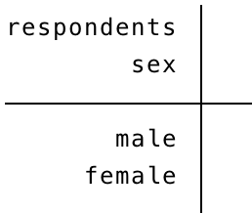
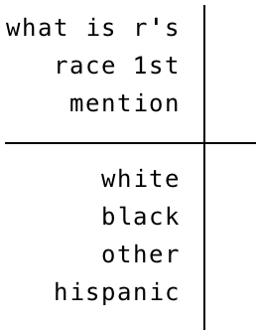
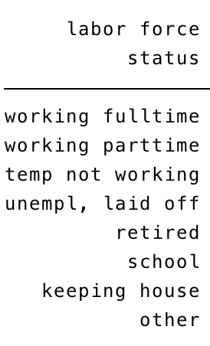
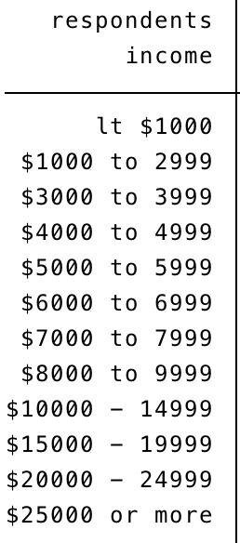
- Race
- Years of education (in years)
- Gender
- Labor force status
- Annual income
- Age of respondent (in years)

Respondent ID | Age
#1 | 44
#2 | 18
#3 | 53
#4 | 44
#5 | 39
#6 | 36
#7 | 22
#8 | 50
#9 | 65
#10 | 73
            - Raw Data Tables

Respondent ID | Highest year of schooling
#1 | 16
#2 | 3
#3 | 12
#4 | 13
#5 | 15
#6 | 16
#7 | 12
#8 | 20
#9 | 16
#10 | 20

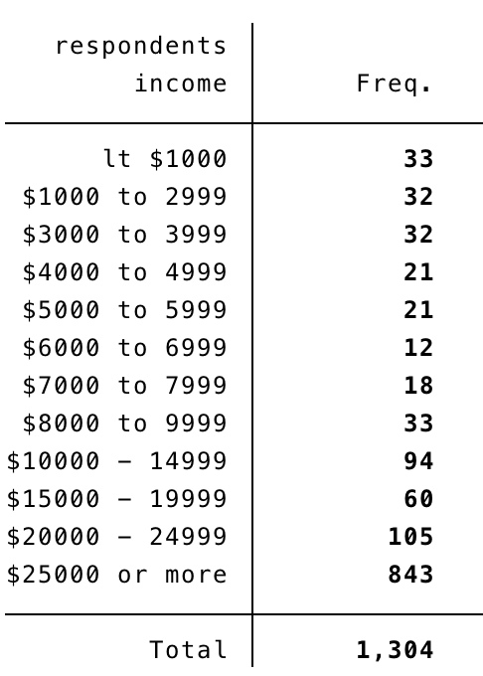
            - Frequency Distribution Tables

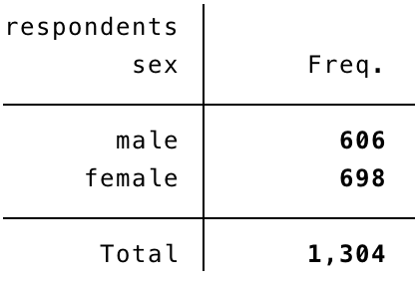
            - Percentage Distribution Tables

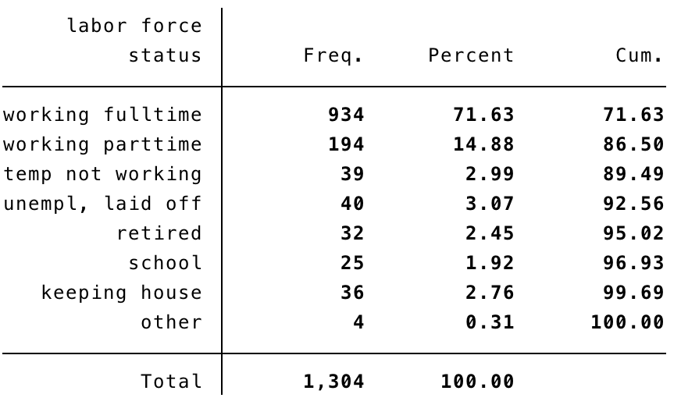
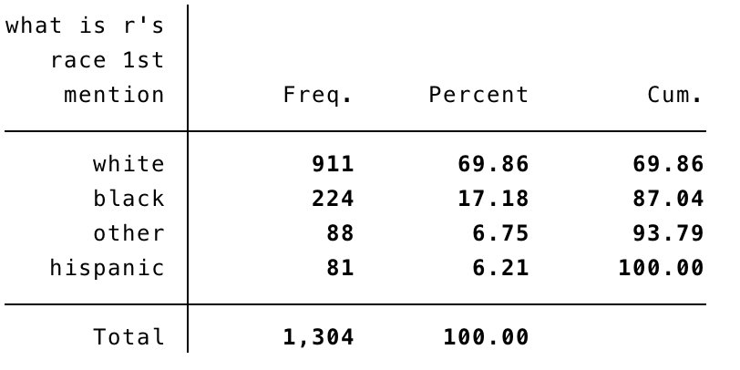
            - Graphs

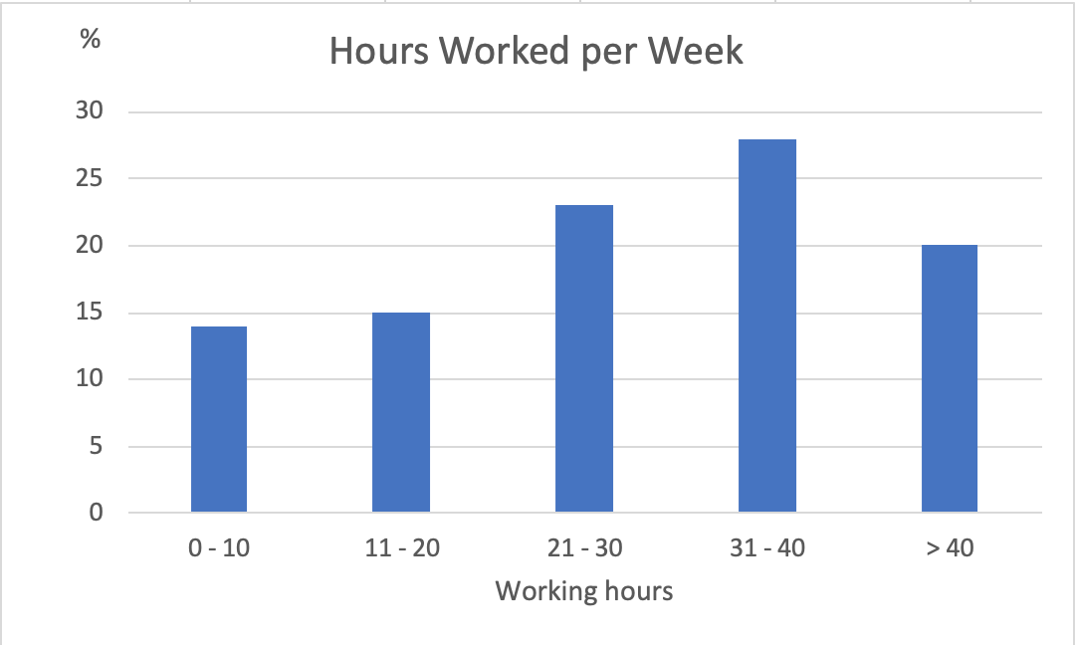

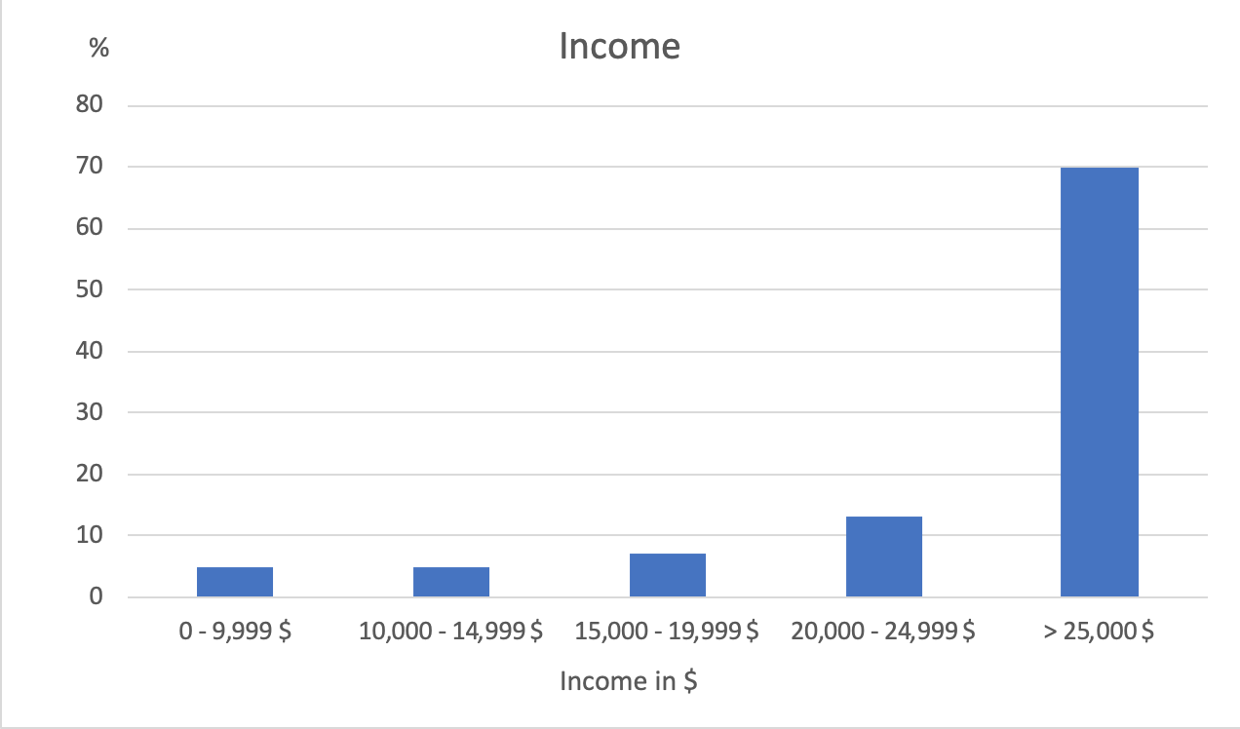
            - Bivariate Table

Table 1: Respondent’s income by gender

Respondent’s income | Male (in %) | Female (in %) | Total (in %) | Male(cumulative) | Female(cumulative) | Total (cimulative)
Less than $1000 | 2.31 | 2.72 | 2.53 | 2.31 | 2.72 | 2.53
$1000 to $2999 | 1.49 | 3.30 | 2.45 | 3.8 | 6.02 | 4.98
$3000 to $3999 | 1.49 | 3.30 | 2.45 | 5.29 | 9.32 | 7.43
$4000 to $4999 | 1.65 | 1.58 | 1.61 | 6.94 | 10.9 | 9.04
$5000 to $5999 | 1.32 | 1.86 | 1.61 | 8.26 | 12.76 | 10.65
$6000 to $6999 | 0.17 | 1.58 | 0.92 | 8.43 | 14.34 | 11.57
$7000 to $7999 | 0.99 | 1.72 | 1.38 | 9.42 | 16.06 | 12.95
$8000 to $9999 | 1.98 | 3.01 | 2.53 | 11.4 | 19.07 | 15.48
$10,000 to $14,999 | 4.95 | 9.17 | 7.71 | 16.35 | 28.24 | 23.19
$15,000 to $19,999 | 2.97 | 6.02 | 4.60 | 19.31 | 34.26 | 27.79
$20,000 to $24,999 | 7.59 | 8.45 | 8.05 | 26.9 | 42.71 | 35.84
$25,000 or more | 73.10 | 57.31 | 64.65 | 100 | 100 | 100
Total | 100.00 | 100.000 | 100.00

